Changes
- Logo seems incorrect especially N. Can we have bigger logo and add International below the logo. That way it will match the domain.
- Overall look of the website does not give impression of outsourcing company.
- Menu – Services should come before the delivery models, and it will match with the menu at the bottom.
- Can we pls remove Australia name from the website. We want to give global prospective for the website.
- Font style and size should be bigger for the main heading.
- Content is not utilizing entire space a lot of space left blank on left and right side.
- Head office Contact details
  - Address – NICS Prince Centre 4th Floor Left wing 709, Pathari Road, Anna Salai, Chennai, Tamil Nadu 600006
  - Phone number
  - vikas@abcdca.com
- Navigation of menu is not functioning properly. For instance, when I’m at the bottom and press home it does not go up.

Home Page
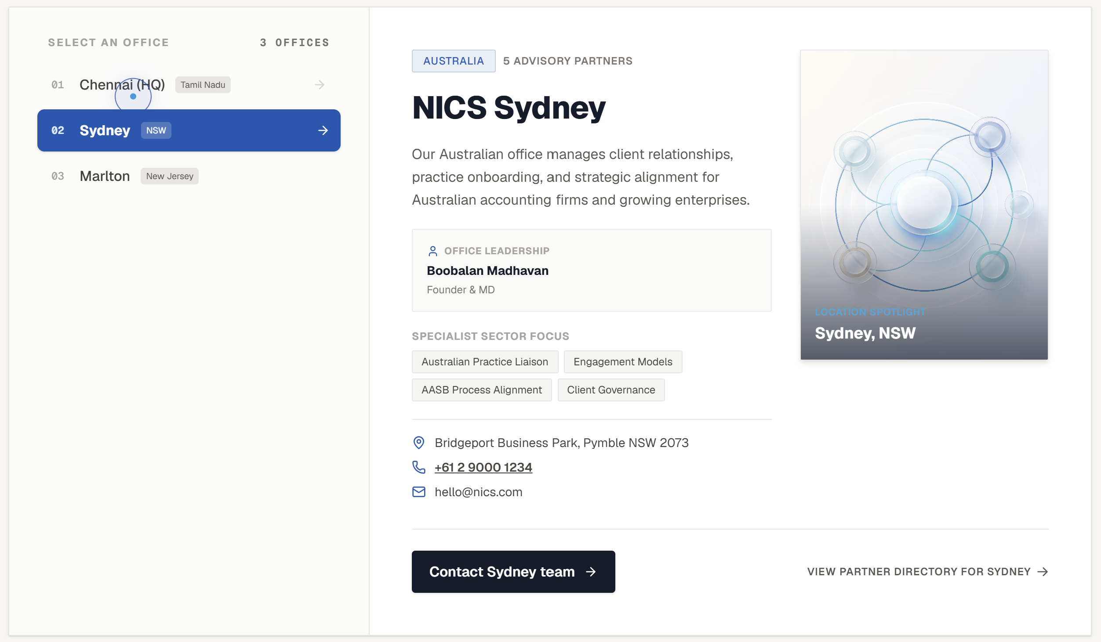

Chennai HQ
Office leader – CA Vikas Jangid
Address – NICS International
Prince Centre 4th Floor Left wing 709, Pathari Road, Anna Salai, Chennai, Tamil Nadu 600006
Contact number - +91 9632 466 477
Email – vikas@abcdca.com
Sydney – let me check with the Rajiv
Marlton – Please remove

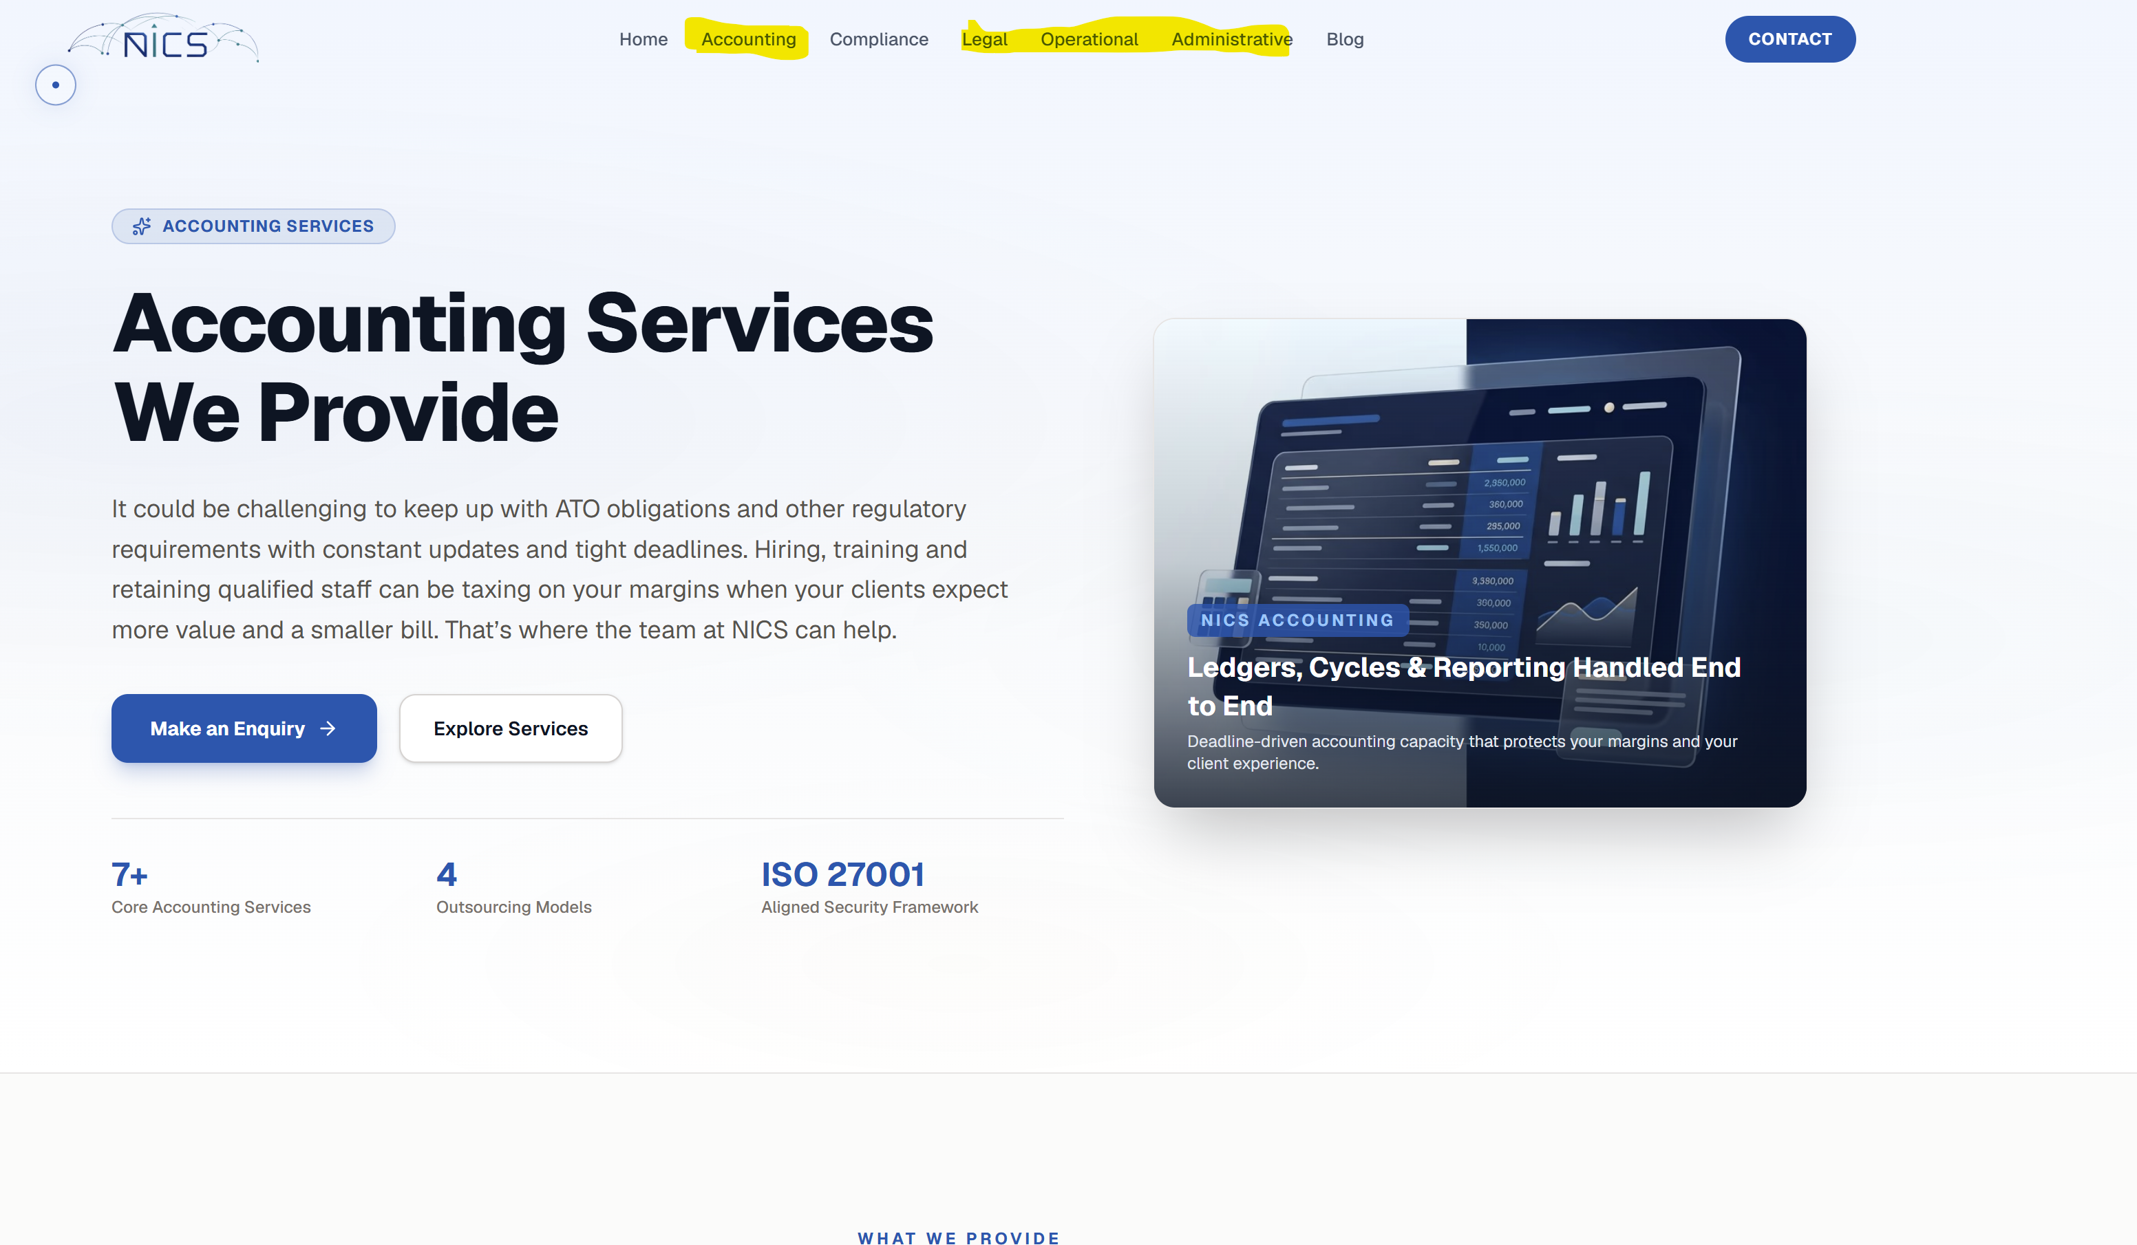
Menu is not in line with the content provided (we do not want yellow one at this point of time)
Header should be part of menu.
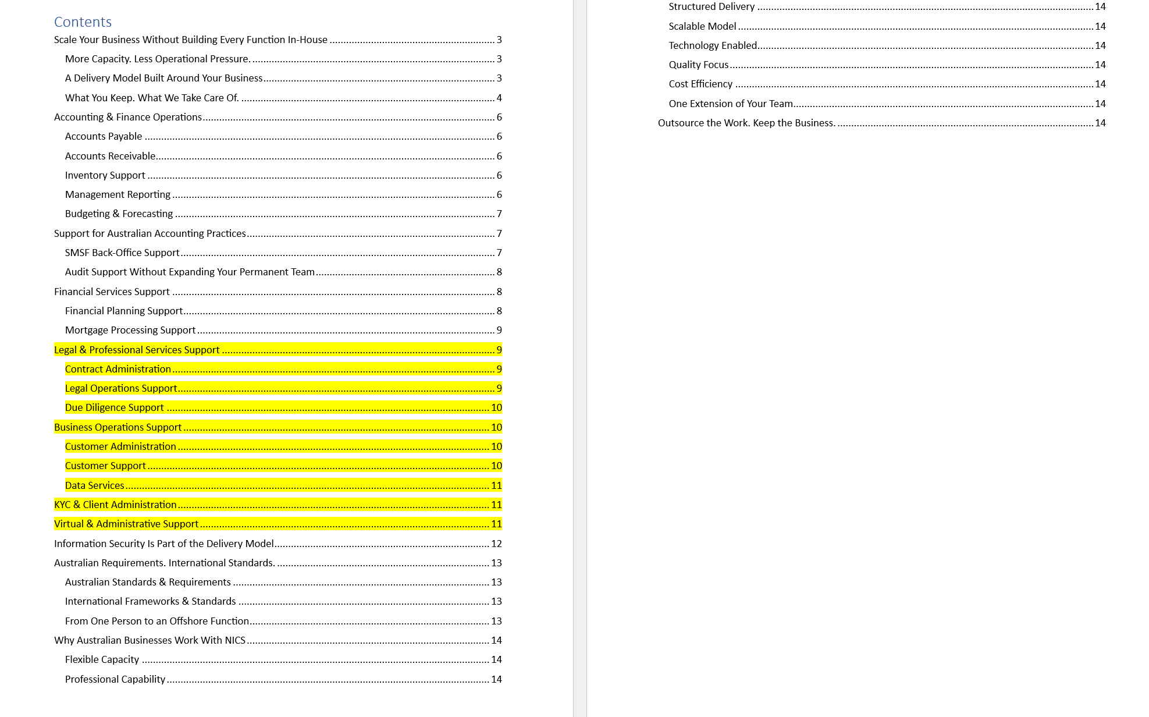

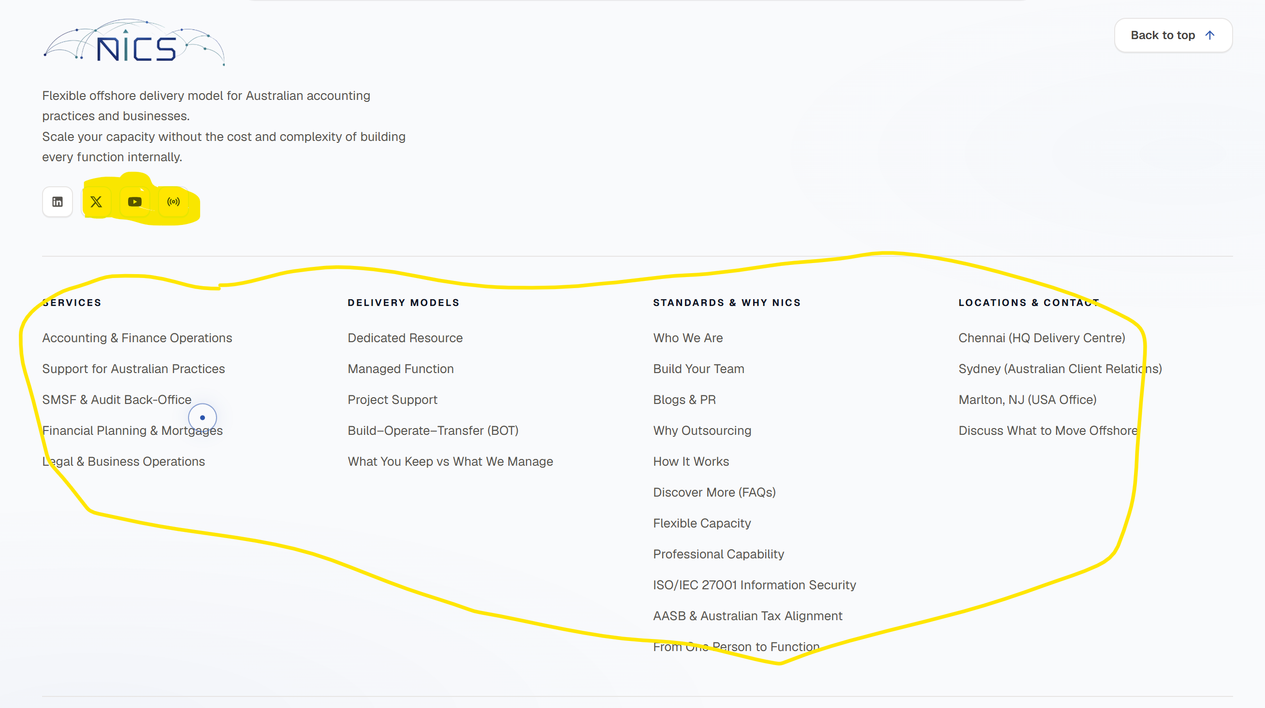
Only keep linked in – other platform we might not operate.
The content in the circle
- some are functioning some are not.
- These should be on menu
When we are navigating through the website sometimes it feels like we lost in the maze. Hard to find out what page we are in. look this website (https://www.onetrust.com/platform/) Navigation is easy there.

